

Orchid News
  - Kentucky Orchid Society, Inc.
  - January 2026
  - Louisville, KY

In this Newsletter:
The President’s Corner …………………………. 1
The Vice President’s Corner …………………. 2
January Meeting Information …………………. 3
December Meeting Minutes .…………………… 4
Project Plants: 2025 & 2026 …………………… 4
Holiday Party Wrap-up …………………………… 5
Newsletter Editor: Michelle Berry michorchid22@gmail.com

The President’s Corner
Letter from the President:

Happy New Year to all my orchid friends! I hope you all had a warm and happy holiday with family and friends!

It is time to start thinking about the things we should do for our plants this time of year. They are not growing as actively as in the summer and thus don't need as much fertilizer or water as they needed 6 months ago, so cut back as appropriate for your environment. If you are growing under lights, they need about 12 hours of light each day during the winter, with a gradual increase to 16 hours by summer.

Phalaenopsis should be setting spikes about now, so be sure to stake those spikes and keep their orientation to the light source consistent so that the spike does not twist around and lose its lovely arch! This will pay off with a lovely presentation later in the spring when we take these plants to regional shows.

Paphiopedilum and Phragmipedium should be repotted over the next couple of months. They do best if they are re-potted annually.

We will meet for our monthly meeting on Wednesday, January 14 and will hear from Tara Littlefield, a PhD student who will talk with us on "Native Orchid Conservation in Kentucky". She works with Dr. Lawrence Zettler, who has spoken with us on a couple of occasions on his work in preserving native orchids in the Everglades and Cuba, specifically the Ghost Orchid.

If you cannot join us in person, here is the Zoom connection. Expect the presentation by Ms. Littlefield to be at about 7 pm.

KOS Admin is inviting you to a scheduled Zoom meeting.

Topic: KOS January 2026 Zoom Meeting
Time: Jan 14, 2026 06:30 PM Eastern Time (US and Canada)
Join Zoom Meeting
https://us06web.zoom.us/j/4911551123?pwd=ZnV2b3VFR3dSYUFnUlcwU2hEVjR2UT09&omn=86050771041

Meeting ID: 491 155 1123
Passcode: 021021

Jan Smith, President
jansmithroberts@gmail.com

The Vice President’s Corner
Letter from the Vice President:

Do you know that Kentucky has over 40 native orchid species? Many of these are slipper orchids, including Cypripedium kentuckiense. (see photo). But ,there is a great deal of variety in the native orchids. Check out the photo below of the Platanthera peramoena A. Gray, also known as the purple fringeless orchid. Unfortunately, there are environmental stressors on these lovely plants, as there are on so many native species. Our speaker this month will address some of these issues. We have spoken in our meetings recently about visiting sites this spring where native orchids grow. Tara may be able to give us some ideas about where to go to see them. She says she is interested in talking with people who grow tropical orchids, as well!

"Native Kentucky Orchid Preservation" is the title of the presentation by PhD student Tara Littlefield, who will visit us from Frankfort, Kentucky. She is studying native orchids as part of her PhD research at the University of Kentucky, under the guidance of Dr. Larry Zettler from Illinois College. He has spoken to KOS on a couple of occasions in the past regarding his study of the threatened Ghost Orchid in the Everglades and in Cuba. KOS has donated to his research efforts on a couple of occasions, to help fund undergraduate students who help in data collection from the Everglades.

It will be exciting to hear from someone studying our own native Kentucky orchids!

Her bio: Tara Littlefield is a botanist, ecologist, and biodiversity leader focusing on preventing species loss and conserving natural areas in Kentucky and the broader Southeastern United States. She currently directs the Biological Assessment & Conservation programs at the Office of Kentucky Nature Preserves and leads a statewide team of biologists that work across conservation assessment, species research, biological inventory, and the restoration of rare species and natural communities. Tara coordinates Kentucky’s Plant Conservation Alliance, linking in situ and ex situ rare plant conservation and building partnerships around shared botanical priorities. A PhD candidate at the University of Kentucky, her research focuses on the restoration of native orchids and pollinators. She serves on the board of the Kentucky Native Plant Society and as a scientific advisor to the Kentucky Natural Lands Trust.

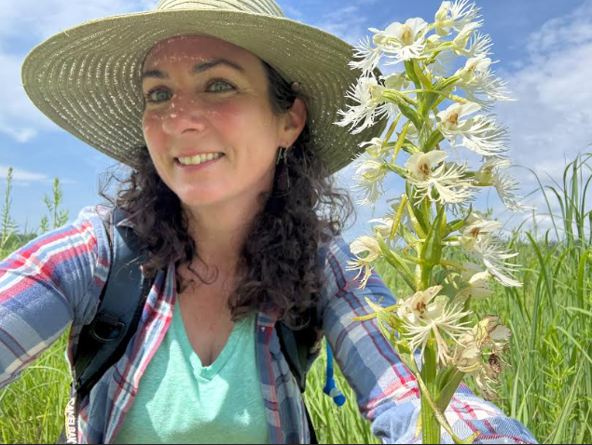

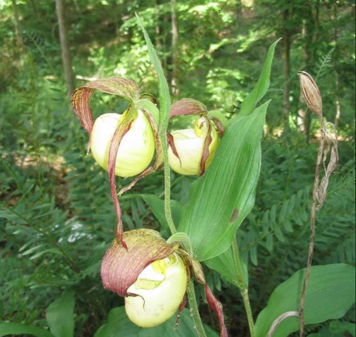

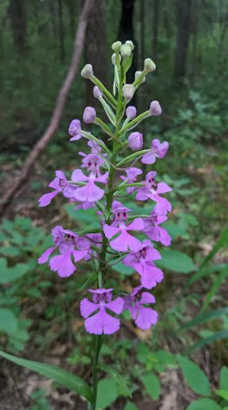

Jennifer Coy, Vice President
jenn_koi@hotmail.com

KOS January Meeting
Second Wednesday of the Month

Date: January 14, 2026
Time: Beginner’s Corner & Social time –
6:15pm
Business meeting – 6:45pm
Program – 7:00pm
Format: In person and on zoom
Location: All Peoples Unitarian Church,
4936 Brownsboro Rd, Louisville, KY 40222
Zoom Meeting:
Topic: KOS January 2026 Zoom Meeting
Time: Jan 14, 2026 06:30 PM Eastern Time (US and Canada)

Join Zoom Meeting
https://us06web.zoom.us/j/4911551123?pwd=ZnV2b3VFR3dSYUFnUlcwU2hEVjR2UT09&omn=86050771041
Meeting ID: 491 155 1123
Passcode: 021021

December Meeting Minutes
KOS Meeting Minutes, December 10, 2025

Meeting was called to order by Jan Smith.
Minutes were approved.
No treasurer report.
Election of officers was completed.

ANNOUNCEMENTS:

- There will be an auction at the Cincinnati Judging Center on Sunday at 11am.
- No Home & Garden show participation this year. We are investigating other options.
- Jan gave a wrap of what the Society has done over the last year.
- Awards for Show & Tell: Beginner: 1st Jan Rager, 2nd Yiana, 3rd Ethan
- Intermediate: 1st Stu, 2nd Linda, 3rd Danetta
- Experience: 1st Larry Atwood, 2nd Anne-Marie, 3rd Michelle Berry
- Grower of the Year: Anne-Marie
- JAPS Award: Walter & Anne-Marie
- Most Improved Grower: Michelle Berry
- A good meal and good time were enjoyed by all.
Danetta Willias, Recording Secretary
danettabw@gmail.com

Club Project Plants:
2025 & 2026

2025 Project Plants

What a fun night! I loved seeing all those baby Oncidiums growing so well. Since everyone was
not able to attend, here’s the list of plant name from 2025.

A- Odcdm. Catante ‘Kilauea’
B- Onc. Aka Baby ‘Raspberry Chocolate’
C- Onc. Pacific Sunrise ‘Hakalau’ (mini)
D- Odcdm. Parquet ‘Uptown Girl’
E- Wil. Eye Candy ‘Pinkie’
F- Wil. Tan Treasures ‘Lavendar Picotee’
G- Oncidioda Pacific Pagan ‘Kiauea’
H- Oncda. Copper Scarab ‘Brass Brethren’
If you need a name tag for your plant, please contact me.

2026 Project Plants

Bulbophullum Worayuth White Fang x Bulbo. zamburgense was distributed to all members who
attended the meeting and had paid their 2026 dues. If you didn’t get one and have paid the
2026 dues, please contact Jan Smith to get yours while quantities last.

Seed Parent: Bulbo. Worayuth White Fang
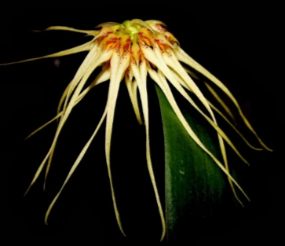

Pod Parent: Bulbo. Zamburgense
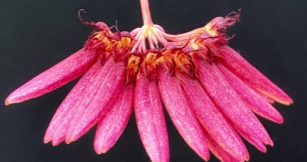

If you got one of the little tolumnia’s I handed out and missed the name, it’s Tolumnia velutina.

Happy Growing!

Pam LaRocco

Holiday Party Wrap-up
Pictures by Sal Loccascio

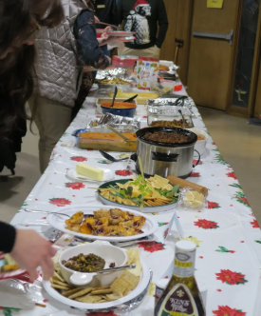

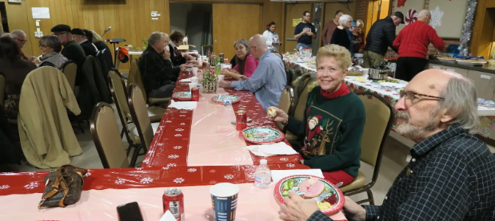
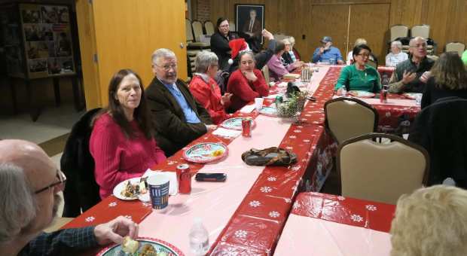

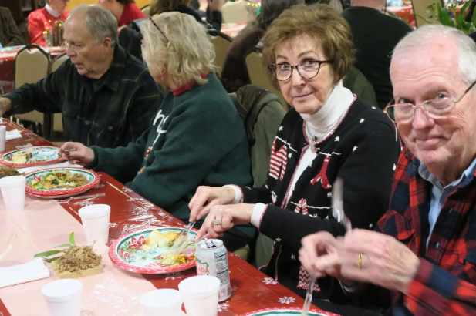

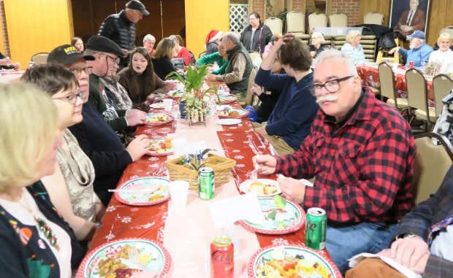

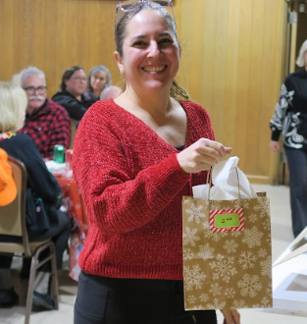
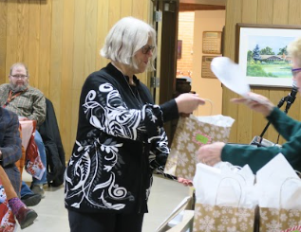

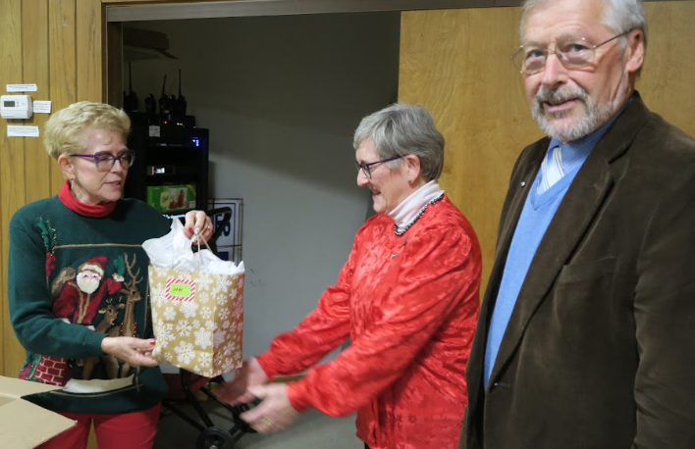

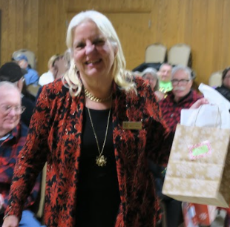

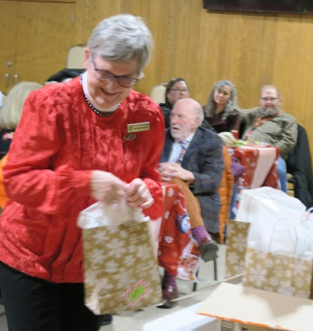

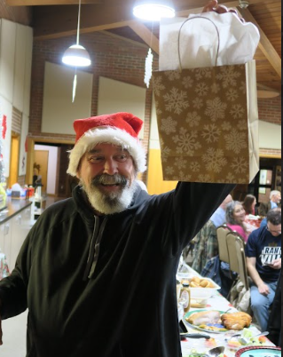

Visit us at our website www.kyorchidsociety.com or on Facebook at Kentucky Orchid Society

